Parish Profile of Kirkconnel linked with Sanquhar: St Bride’s

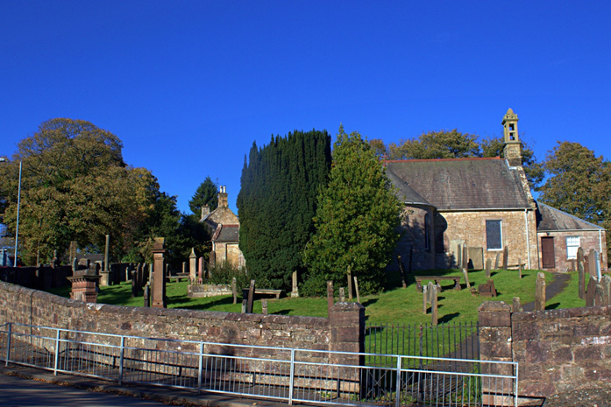
Kirkconnel Parish Church
Introduction
Kirkconnel Parish Church was built in 1729 and is situated in scenic Upper Nithsdale on the A76 Dumfries to Kilmarnock trunk road. The Parish takes in the villages of Kirkconnel and Kelloholm as well as many outlying farms.
Kirkconnel village has a small number of shops which includes a post office which is situated within the local premier store. Kelloholm has a primary school and health centre, all of which are within easy walking distance of each other. Kelloholm is also the site for Brown Brothers, Upper Nithsdale’s largest employer.
Church Life
Kirkconnel Parish Church was linked with St Bride’s Church Sanquhar in November 2016, in line with the Dumfries and Kirkcudbright Presbytery plan. We are now prayerfully seeking to appoint a new Minister on an unrestricted tenure.
We have a Congregational Roll of 215 with an average Sunday attendance of 30-35.
Our weekly Sunday Service takes place at 11.30 am This will change to 10am in January as the service times alternate between the two churches each year. We celebrate Holy Communion 4 times a year in March, June, September and December on the first Sunday of these months.
We host the annual Guides Thinking Day in February each year and we have our annual Remembrance Day Service at the war memorial followed by a service in the church. We also have an annual open-air service in June at the site of the original St Conal’s church which is situated at the foot of the Kirkland hill about 2.5 miles from the site of the church we worship in today. At our annual Harvest Thanksgiving Service we ask the
congregation for a retiring offering which is then given to charity. This year it went to
Cross Reach at Morven House in Kilmarnock
We have a coffee morning once a month which we call ‘coffee and chat’ which is run by a dedicated group of ladies in the congregation. This generates income for our church. We also have a church box scheme whereby church members and non-church members can request a box that they can collect loose-change for church funds. Last year this generated £6000.
Church Management
We have a Kirk Session consisting of 12 elders who also serve on the Congregational
Board and a further 3 Board Members who are not elders. Together they form our Church Trustees. Maintenance of the Church building and its surroundings is important to us. The Church building is well maintained. We do not have a church hall.

Manse
The manse is situated in Sanquhar and is included in St Bride’s Church Profile.
Conclusion
Although we are an ageing congregation, we are a forward-looking congregation and we are always looking for ways to attract younger members of our community to our church
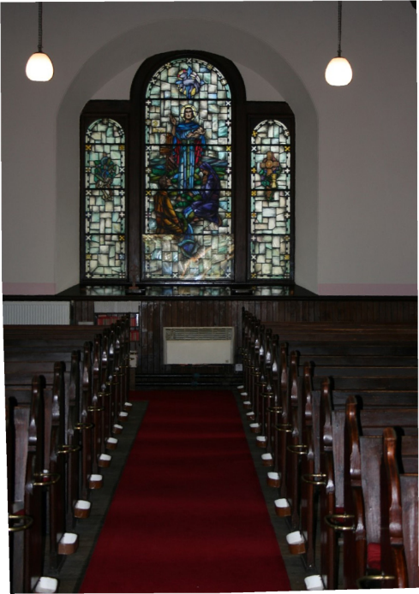 Inside Kirkconnel Church

ST BRIDE’S PARISH CHURCH, SANQUHAR.
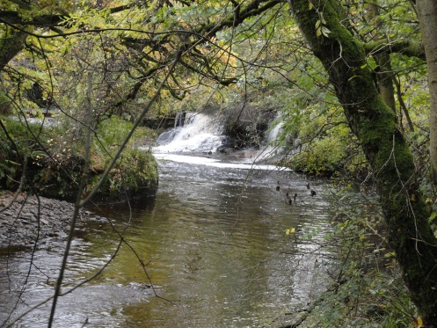
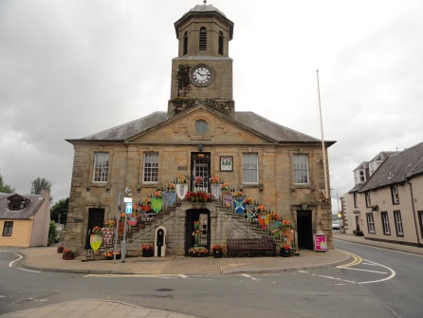
Sanquhar sits among the high hills and secluded glens and valleys of Upper Nithsdale in Dumfries and Galloway. Created a Royal Burgh in 1598, the town boasts an interesting history, with a 12th Century Castle at the southern end, and an early hill fort at the other, the latter giving the town its name “San Caer”, literally the old fort or the old place. Situated some 27 miles from Dumfries and approximately 30 miles from Ayr and Kilmarnock, the area is served by Stagecoach buses and main line trains, making access to both Glasgow and Edinburgh easy. The district is also surrounded by magnificent rolling hills, and with easy access to the countryside, it is a haven for walkers, and those seeking peace and solitude. It is also a major stop-over on the Southern Upland Way, the coast to coast path which runs from Portpatrick in the west to Cockburnspath in the East. The population of the Town is about three thousand, with a primary school and a secondary (Academy) school catering for students up to the age of eighteen. Both schools currently enjoy excellent reputations in the world of education. The High Street of Sanquhar retains many of the original shops and premises from former years, still providing the same services. There is a bank, and a library, with active golf club, bowling club, and the oldest Curling Club in the world. The Post Office too, is the oldest working Post Office in the world and dates from 1712.
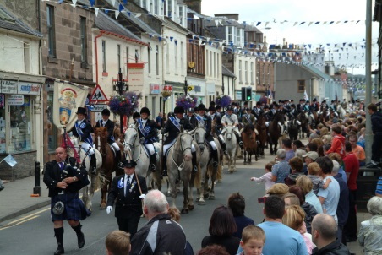
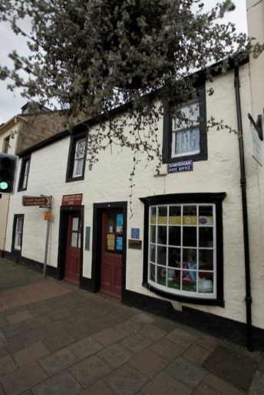
There are three modern supermarkets, plus a butchery, a bakery, and two hotels on the High Street, and a Craft Centre where traditional Sanquhar Knitwear is not only produced but taught. The granite obelisk to Covenanters James Renwick and Richard Cameron is also to be found on the High Street. Sanquhar has a great sense of history and civic pride, and this is doubly apparent during the Riding of the Marches Week, when chosen Principals ride out around the former lands of the Royal Burgh checking them to ensure there has been no encroachment on our Royalty. These ancient customs linger on and enjoy huge support, not only from the residents, but also from many people who return “home” each year to enjoy the festivities. St Bride’s Church plays an important part in these festivities. The town offers a wide range of social activities, with most clubs and societies particularly active over the winter sessions. SWI, Heritage Society, Guild, Badminton, Highland Dancing, are among the winter activities, and the Upper Nithsdale Craft Centre, “A’ the Airts”, runs classes in practically every subject from knitting to painting and pottery. Provision is also made to teach children craft and design, with supervised classes available in the modern arts facility.
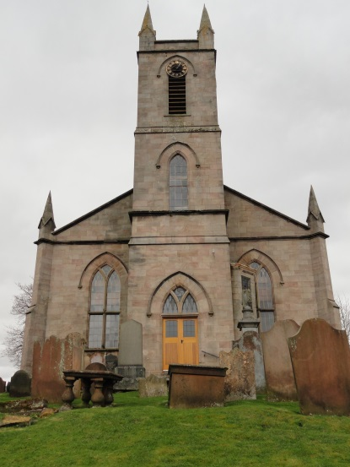
St Bride’s Church occupies a prominent position on a small hill at the western end of the town and is one of the first buildings seen on approach to the town. The church is a large building, originally a “box” design, but this was changed in 1929 when the soaring chancel was added. With seating for over eight hundred, it is larger than required; and after a winter or two with roof problems, application was made to the Heritage Lottery Fund for assistance in repairing the roof. This application was successful and a sum of over £217000 was granted early in 2018, and despite an excellent summer for repair work, shortage of compatible slates meant the work could not go ahead. The church sits in a Conservation Area, and is also B listed, but at the time of writing, a suitable source of slates has been identified and work on the roof commenced in February 2019. Work involves masonry and roof work on the Tower, and a full overhaul/renewal of all leadwork and rain water goods. This work should be completed by the end of July 2019. The Congregation has independently raised large sums in order to take this project forward, and in keeping with the requirements of Historic Environment Scotland, the transept will house a display of church heritage items, collected over the years. The church also contains some very fine stained glass, all executed by the Glasgow firm of JT and CE Stuart. The glass is noted for its magnificent colours obtained by a secret process only known to the father and son team of Stuarts. There is a very fine Hilsdon pipe organ also built in Glasgow in 1931, and recently surveyed by an organ expert who delivered a glowing report of the organ’s condition and tone. There are toilet facilities at the front door and in the vestry. There is also a Session Room upstairs. The building is heated by gas. Disabled access is via the side door.
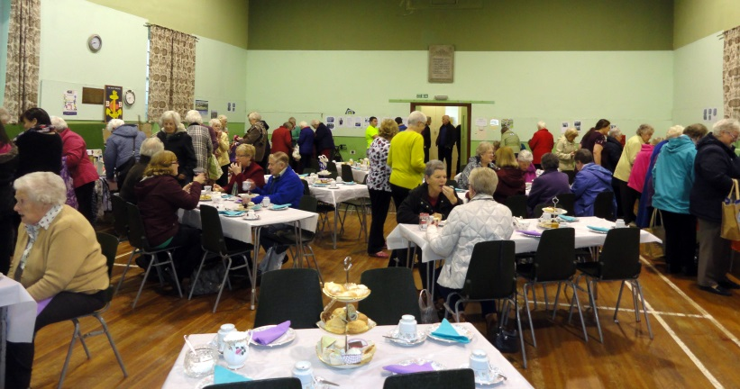
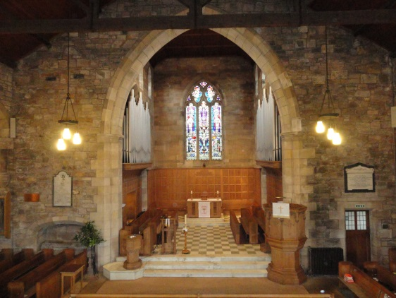
The Church Hall The former North U.F. Church of Sanquhar where Covenanting historian Rev Robert Simpson DD was minister for some 48 years, the building was bought/gifted and re furbished in the early 1950s and became our church hall. The main hall is large, and has a full unobstructed badminton court while the small hall can accommodate meetings and smaller groups with a capacity of about sixty seats. There are adequate kitchen and toilet facilities, with a further room at the back which at one time housed a billiard table. Disabled access has been provided over the past few years, and the Hall complex is centrally heated by gas. The hall is situated in the centre of the town, 300 metres from the church. The complex is well used by both church organisations and other town groups, and is generally in good condition.

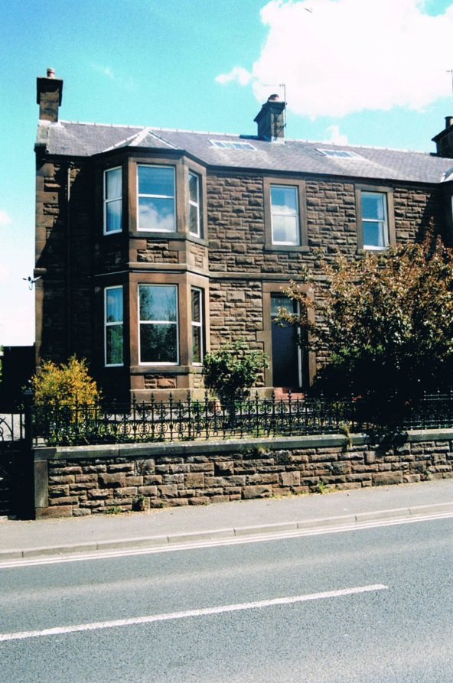
The Manse The current St Bride’s Manse is a substantial sandstone building fronting on to Glasgow Road, with a back entry from Church Road. It is located a short distance from St Bride’s Church and about the same distance from the High Street shops. However, since the linkage with Kirkconel Parish Church, both congregations agree that a more modern, convenient family home be purchased by both congregations and the current manse sold. As the new manse has not yet been purchased, there are no photographs, but both congregations will ensure that the new building surpasses the accommodation requirements for Church of Scotland ministers. Both congregations realise this is an opportunity to provide a high class home for our incoming minister.

The Congregation
As with many churches, the average age of the congregation is creeping upwards, yet there is still a youthful outlook among church members and a great sense of belonging to the church, which is a focal point of the community. Weekly attendances at Sunday worship exceeds fifty members rising to several hundred for special services such as Remembrance Sunday. It is a challenge to attract teachers for the Sunday School, and also Officers for the Boys’ Brigade. During recent fund-raising for the church roof, it was amazing how many people still identify with the church, and many local groups gifted large sums of money for the project. Similarly, whenever a needy cause arises, the church has risen to the occasion. St Bride’s has supported an Aids Orphanage in Matatiele, South Africa for many years and made a real difference to the lives of many unfortunate children.
We have passed on our knowledge of the Matatiele children, and several other churches and groups also continue to donate to alleviate suffering and need. Each year, our Harvest Thanksgiving Gift goes directly to the Orphanage, and there are several generous individual donors within our ranks.
The Church holds two special outdoor services each year. The Kirkbride Preaching is held in August at a ruined church high in the hills overlooking the Nith Valley. Kirkbride Parish was suppressed in 1725, and was a place of safety for the Covenanters during the “Killing Times”. Originally started in the early 19th Century, the traditional “Preaching “ continues today, shared by St Bride’s and Durisdeer Parishes who now also share the Parish of Kirkbride! St Bride’s also holds an outdoor conventicle, usually at the head of Euchan Water which was a haunt of Covenanters in years gone by. This July service is always followed by a Church Picnic.
The Church operates under the Model Constitution, and there is an active Board and Kirk Session. St Bride’s is a strong supporter of the Mid and Upper Nithsdale Elders’ Union, a unique body which meets three times a year at churches all over the area. Elders (Board Members are now also included!) learn about specific Christian involvement in schemes all over the world, and also know and socialise with their peers from other churches.
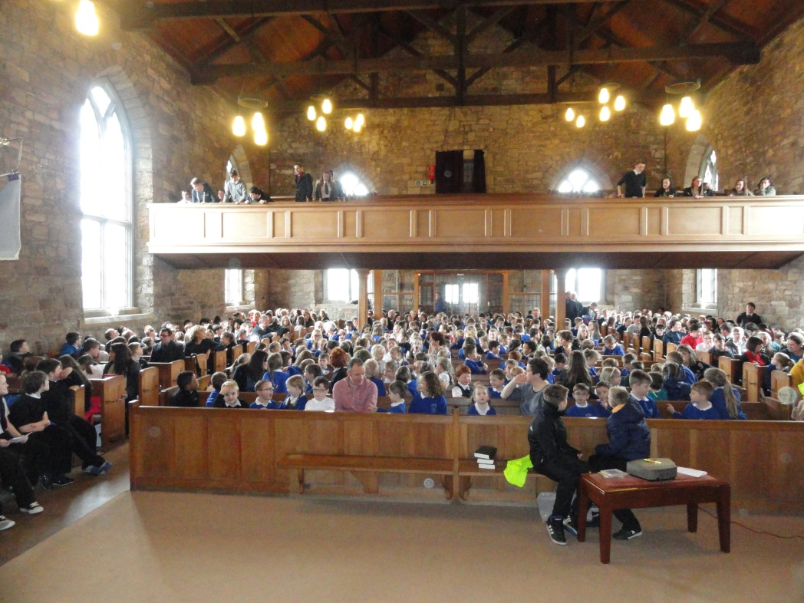

The Primary School in Church 2018

The Church has the largest seated accommodation in Upper Nithsdale, and it is normal for both Academy and Primary School end of term services to be held in St Bride’s. Picture above shows a full church with Primary School Pupils.

Academy Students in Church 2018

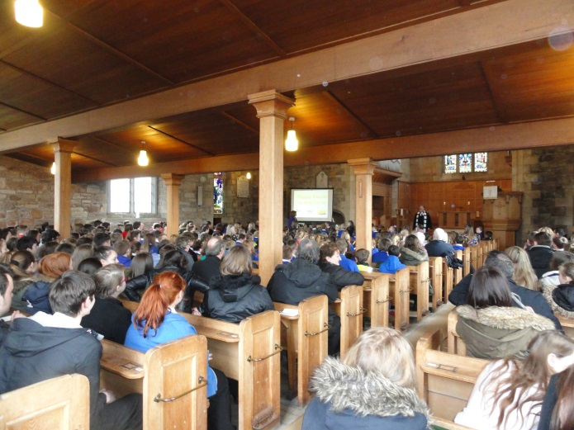

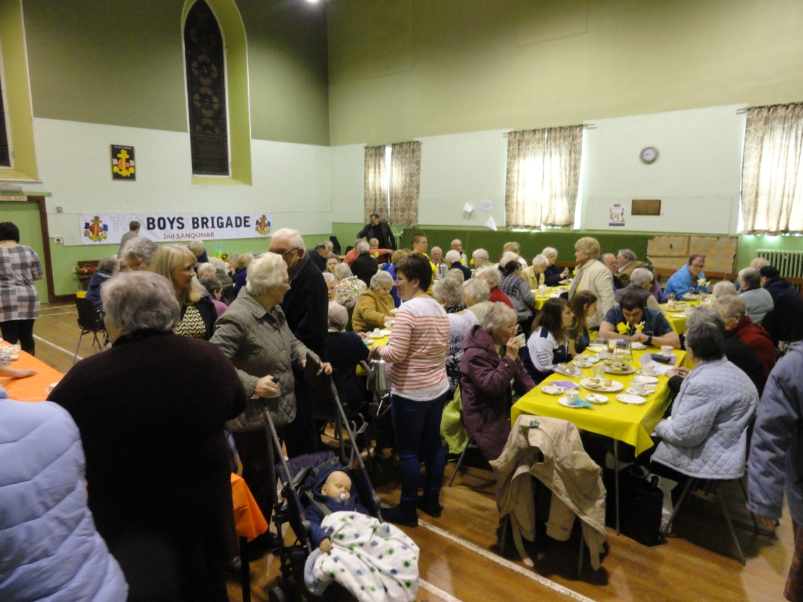
The Daffodil Tea is one of the Main Fund-raisers of the year. It is organised by the Guild with the help of many friends from the community. There is also an active St Bride’s Bowling Club, which is well attended.
A Badminton Club caters for those with an active life-style.
Various other non-church groups also have the use of the hall.

OUR MINISTER?
What kind of minister would we like for the linked charge of Kirkconnel and St Bride’s? Both communities are fairly conservative, and prefer traditional type services and music. That’s not to say we wouldn’t appreciate a different style of service, it is merely what we are used to! We would welcome either a male or female minister—and age is not an issue, though obviously we would like a minister who would stay for some time! It would be an added bonus if we could once again attract some of the younger members of the community, for there is a large pool of children who attend our church hall for various activities and it is felt that they could be encouraged to return to church. The church hall complex in Sanquhar has excellent facilities which could be utilised to encourage youngsters to attend church-led activities. The pictures above show the number of children available to attend church or church related events.
Above all, we would appreciate a minister who wishes to become part of the local communities, and take part in the life of the towns. We feel we can offer a great life style, amidst very welcoming and genuine people who respect their minister and would offer support to him or her throughout their stay in Upper Nithsdale. The local people are kind and considerate, and the churches of both Kirkconnel and Sanquhar offer inspirational surroundings to a new minister.
We would appreciate a minister with a keen sense of humour, and a realistic view of the world outside the church. We need someone who can lead, and it is certain they will be well pleased by the response they get from the church members, and from others within the parishes.

